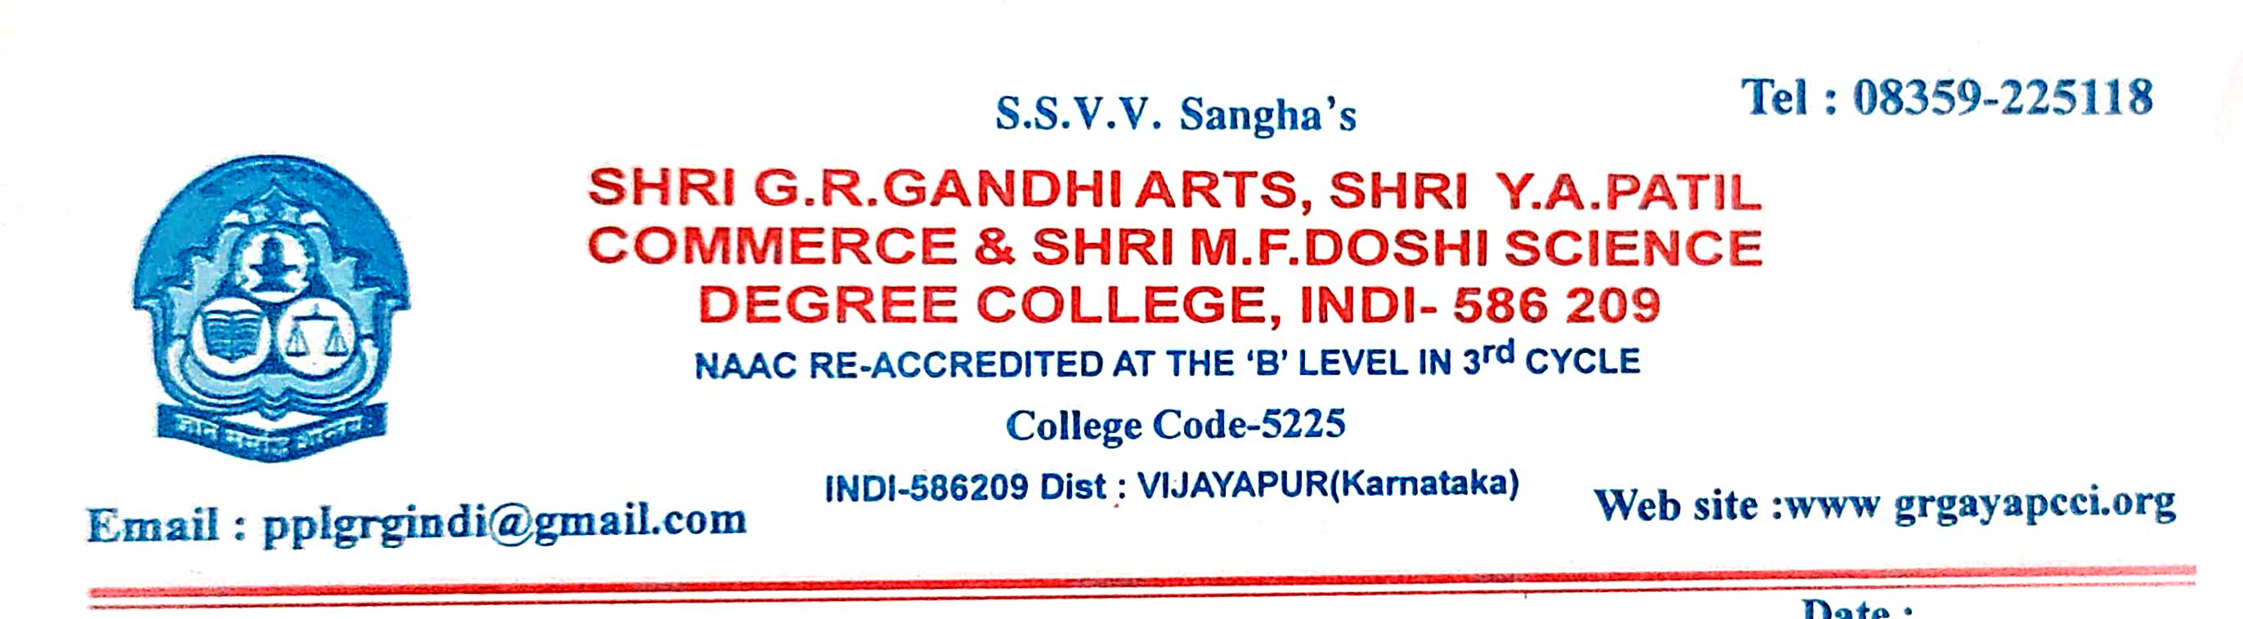
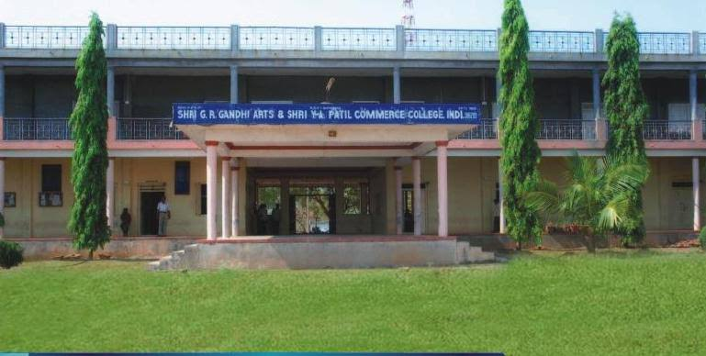
CRITERION VII - INSTITUTIONAL VALUES AND BEST PRACTICES
7.1.10 - The Institution has a prescribed code of conduct for students, teachers, administrators and other staff and conducts periodic programmes in this regard.
1. The Code of Conduct is displayed on the website
2. There is a committee to monitor adherence to the Code of Conduct
3. Institution organizes professional ethics programmes for students, teachers, administrators and other staff
4. Annual awareness programmes on Code of Conduct are organized
CODE OF CODUCT COMMITTEE 2021-22
The staff meeting was convened by principal on 08/06/2021 at 8:00 am, reference and finalised the code of conduct of student and staff. The meeting was successfully attended by all the teachers,faculties including NAACand IQAC Co-ordinator the meeting proceeding helped the institution to finalised and publish code of conduct for students and staff. Members who actively participated and contributed their views and suggestions for framing the code of conduct.
SI.NO | NAME | DESIGNATION
1. | Prof.S.B.Jadhav Principal | Chairman
2. | Dr.Jayaprasad D | Co-ordinator
3. | Dr.V.A.Korwar NSS Officer | Member
4. | Dr.P.K.Rathod Economic Dept. | Member
5. | Smt.B.B.More Science Division | Member
6. | Smt.Shweta kant Science Division | Member
7. | Parvati mala | Student Representative
8. | Ramchandra jamadar | Student Representative

Notice
All the members of code of conduct monitoring committee are hearby informed to attend meeting on 08/06/2021 at 11:00 am, in IQAC room.

1. | Prof.S.B.Jadhav Principal | Chairman
2. | Dr.Jayaprasad D | Co-ordinator
3. | Dr.V.A.Korwar NSS Officer | Member
4. | Dr.P.K.Rathod Economic Dept. | Member
5. | Smt.B.B.More Science Division | Member
6. | Smt.Shweta kant Science Division | Member
7. | Parvati mala | Student Representative
8. | Ramchandra jamadar | Student Representative

Agenda:
- To prepare policy document on code of conduct for student and teachers.
- To create awareness among students about code of conduct.
- To monitor adherence to the code of conduct.
- Any other monitor with the permission of the chair.

CODE OF CONDUCT COMMITTEE MEETING 2021-22
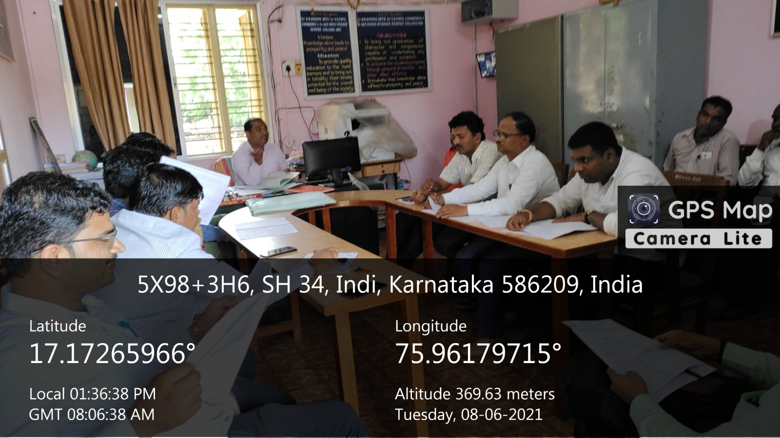

CODE OF CONDUCT

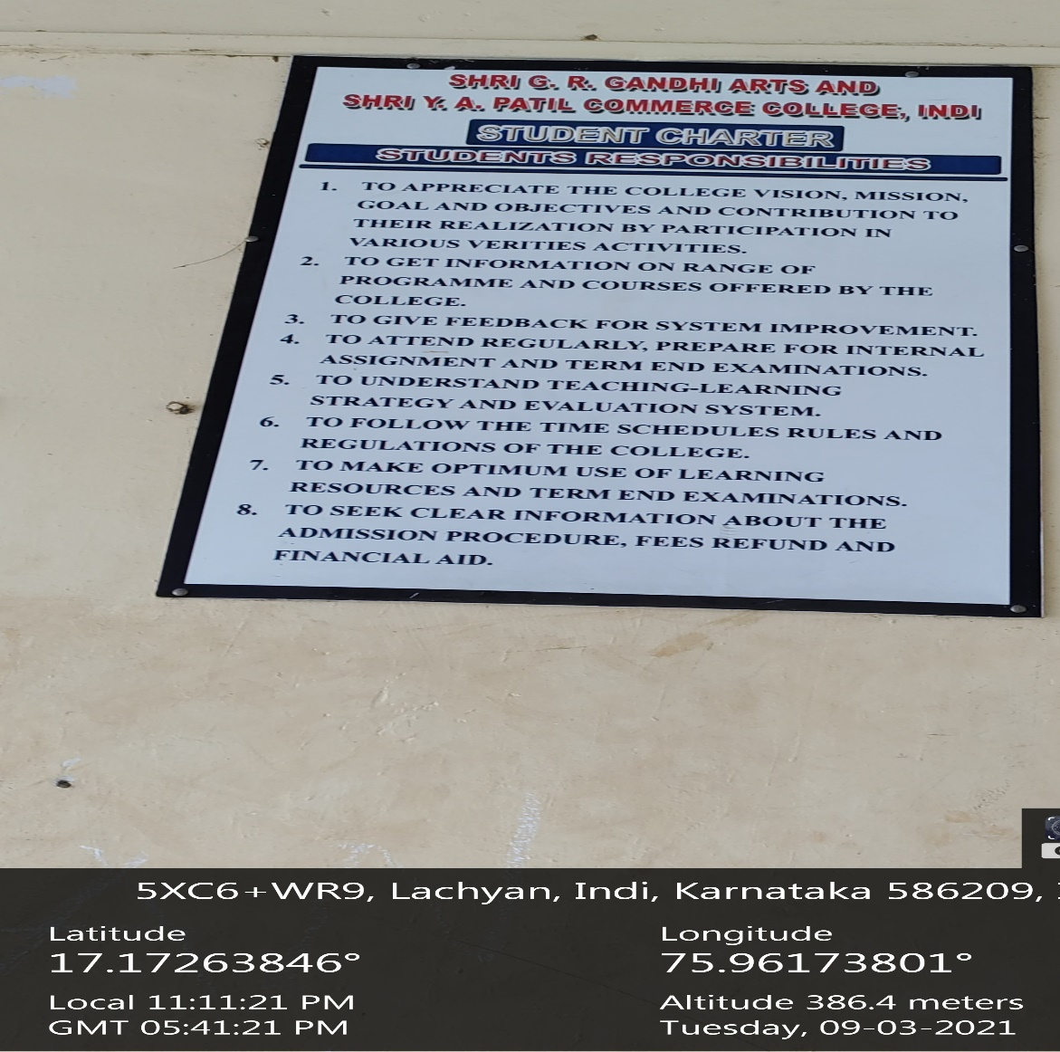

CODE OF CONDUCT COMMITTEE MEETING 2021-22
FOR STUDENTS
